Q1 Find the shortest path from the given source S to all other vertices in the

given graph using Dijkstra algorithm.

Start from source S=A.

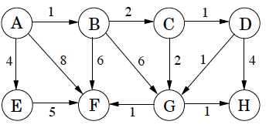

Q2 Explain spurious hits in Rabin-Karp string matching algorithm with example. Working modulo q=13, how many spurious hits does the Rabin-Karp matcher encounter in the text T = 2359023141526739921 when looking for the pattern P = 31415?

Q3 Differentiate between Breadth first search & Depth First search.